

SEMESTER

INTERNSHIP

ANDHRA

PRADESH

STATE COUNCIL OF

HIGHER EDUCATION



**SEMISTER INTERNSHIP PROJECT REPORT ON**

**BUILDING A BLOG APP**

**BACHELOR OF TECHNOLOGY**

In

**COMPUTER SCIENCE AND ENGINEERING**

Submitted by

**A. HEMA LAXMI - 20T91A0502**

**G.AJAY - 20T91A0525**

**K.VINAY - 20T91A0537**

**M.LAKSHMISIVATMIKA - 20T91A0558**

**A.JAGADEESWARARARAO - 20HK1A0502**

Under the Esteemed Guidance of

**Mr. D. RAMESH , M.Tech (Ph .D.)**

Associate Professor

**DEPARTMENT OF COMPUTER SCIENCE AND ENGINEERING**

**GIET ENGINEERING COLLEGE**

Accredited by NAAC, Affiliated to JNTUK, Kakinada, Chaitanya Knowledge City,

Velugubanda, Rajamahendravaram – 533 296, Andhra Pradesh, India.

2023-2024

**1 INTRODUCTION**

* 1. Overview

A brief description about your project

* 1. Purpose

The use of this project. What can be achieved using this.

1. **LITERATURE SURVEY** 
   1. Existing problem

Existing approaches or method to solve this problem

* 1. Proposed solution

What is the method or solution suggested by you?

1. **THEORITICAL ANALYSIS** 
   1. Block diagram

Diagrammatic overview of the project.

* 1. Hardware / Software designing

Hardware and software requirements of the project

1. **RESULT**

Final findings (Output) of the project along with screenshots.

1. **ADVANTAGES & DISADVANTAGES**

List of advantages and disadvantages of the proposed solution

1. **APPLICATIONS**

The areas where this solution can be applied

1. **CONCLUSION**

Conclusion summarizing the entire work and findings.

1. **FUTURE SCOPE**

Enhancements that can be made in the future.

**1.INTRODUCTION**

* 1. **Overview:**

A blog is an online journal or informational website run by an individual, group, or corporation that offers regularly updated content (blog post) about a topic. It presents information in reverse chronological order and it’s written in an informal or conversational style.

* 1. **Purpose:**

**To Educate Others and Build Online Presence:**

While a blog’s function remains the same, the type of content is more diverse. While many blogs still work like online diaries, some have started blogging to educate others on a specific subject or to build a professional online presence.

Blogging has also become a profitable career choice, especially during the pandemic. In fact, over 50% of blogs gained traffic, and about 35% of bloggers increased their revenue in this period.

**To Help a Business With Brand Awareness:**

Many organizations and businesses use blogs as part of their content marketing strategies to boost brand awareness and increase conversions.

A business’s blog content usually focuses on industry-related information that may interest its target market. Often, a team of writers runs the blog instead of a single admin.

**To Promote Programs And Attract Visitors:**

For instance, many businesses create blogs to promote their programs in the hope of attracting more visitors and leads. We see this often with educational institutions where they try to attract more students to enroll in their programs.

**2.LITERATURE SURVEY**

**2.1 Existing Problem**

**1. No Comments from Visitors/Readers**

It can be very frustrating to dedicate time creating a blog post, only to sit and wait for comments that never come. The interactive aspect of blogging is what draws many people to get started with their own blog, but in reality many new blogs have trouble attracting comments. If you find that your blog posts don’t usually get the attention or feedback that you had hoped for, you’re not alone.

**2. Not Enough Traffic**

Possibly the most frustrating challenge for many bloggers is trying to attract more visitors. In fact, most bloggers don’t give very much thought to how they will attract visitors until after the blog has been launched and they find that not many people are visiting. Regardless of how much traffic you have, you’ll always want more. But for new blogs, this can be a discouraging problem to face, and it’s one that leads many bloggers to give up and stop blogging.

**3. No Clear Purpose**

Every blog should have a clear purpose. If you’re maintaining a personal blog your focus is probably just to communicate with friends and family, so you can pretty much post whatever you want. But if you are blogging for business purposes you should have an idea of what you want to get out of blogging. Many people start blogs because other people are doing it and they feel that it is important, but they don’t always know specifically why.

**4. Very Few Repeat Visitors**

While getting traffic is certainly a concern for many bloggers, repeat traffic really is what is most important to a blog’s long-term success. In order for a blog to achieve and maintain a high level of success, it must be able to build a community. The community of users are people who come to the blog on a consistent basis, hopefully they leave comments at least occasionally, and they’re also more like to share a link or vote for the content on social media sites.

**5. Low Income/Revenue**

If you’re not blogging for personal reasons you most likely want to make money from your blog either directly or indirectly. Although the potential to make money blogging is rather high, in reality only a small percentage of bloggers ever achieve their income goals.

**2.2 Proposed solution**

**1.Leave Comments on Other Blogs**

When I started blogging one of the most effective ways of building an audience and attracting comments was to leave comments on other blogs. I focused on other small blogs rather than industry leaders, because those bloggers were more likely to notice and appreciate the comment, and sure enough, many of them came to my blog and returned the favor.

**2.Re-Evaluate Your Posts**

Take a step back and look at the types of posts that you are publishing to make sure that you’re providing original content that is worthy of attention. What other types of posts could you try? How could you differentiate yourself from other blogs in the industry/niche? Are your posts working together to develop the style that you are hoping to achieve? Are certain types of posts having more success than others?

**3.Think About Why You Want to Blog**

Do you want to blog simply to share your thoughts and opinions? Do you want to use the blog to promote your services? Do you want to sell products? Do you want to build your reputation and position yourself as an expert? Do you want to make money from affiliate products or ad clicks?

**4.Encourage Subscriptions by Email and RSS**

One of the best ways to get readers to come back is if they subscribe by RSS or email. Subscribers will see your content any time something new is posted, so it’s very likely that they will see something they like in their RSS reader or email inbox and return to your site. You can encourage subscriptions by placing links, icons, buttons, or sign up forms in prominent locations on your blog where they will be easily noticed.

**5.Don’t Expect to Make Money Right Away**

Building a profitable blog takes time. It’s extremely rare that a new blog will produce any significant income in the first few months, or even the first year in many cases. Many bloggers expect to see results very quickly, and they get discouraged even though they are making great progress simply because income is low.



**3.THEORETICAL ANALYSIS**

**3.1 Block diagram**

**Diagrammatic overview of the project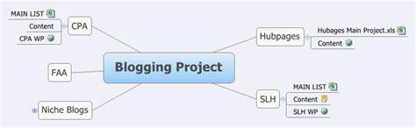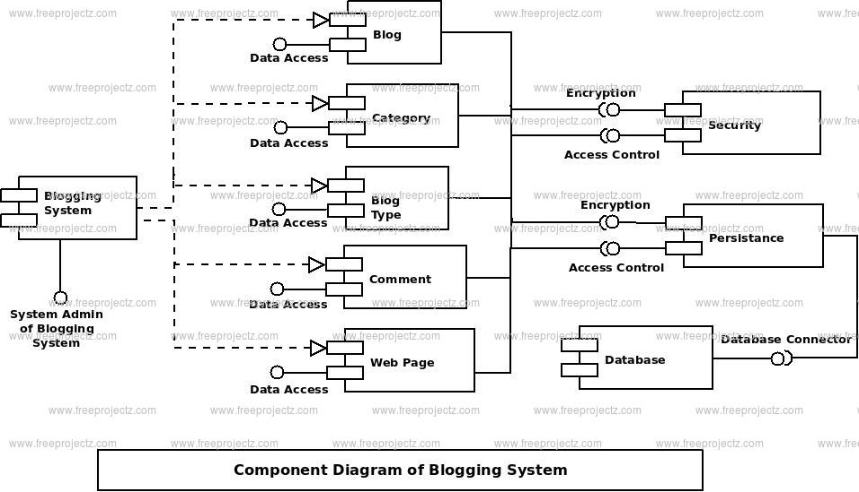.**

**3.2 Hardware / Software designing**

**Hardware and software requirements of the project :**

**Hardware Requirements:**

The hardware you'll need for designing a Blog App is relatively standard and can be found in most modern computers. Here are the essential hardware components:

**Computer:** A reliable and modern computer or laptop is essential. Ensure it has sufficient processing power, RAM, and storage to run web development software smoothly.

**Monitor:** An additional monitor or a larger screen can enhance your productivity, allowing you to see your code and design layout simultaneously.

**Input Devices:** A keyboard and a mouse (or trackpad) are essential for web development.

**Internet Connection:** A stable and fast internet connection is crucial for accessing online resources, libraries, and hosting the website during development and deployment.

**Software Requirements:**

To create a blog application we must have knowledge on HTML(Hyper Text Markup Language) , CSS(Cascading Style Sheets) , JS(Java Script) . And we have to learn the using of Bootstrap . Bootstrap is an a library which having the coding of HTML , CSS , and Java Script . And we have to create Git hub Account .

Git hub is an online software development platform used for Storing , Tracking and Collaborating on software projects . It makes easy for developers to share the coding.

As a web developer , the three main languages we use to build websites are HTML , CSS , and JavaScript.

Java Script is the programming language , we use HTML to structure the site , and we use CSS to design and layout the webpage.

These days, CSS has become more than just a design language , though . You can actually implement animations and smooth transitions with just CSS.

Java Script has also grown beyond being used just in the browser as well . We now use it on the server thanks to Node.js.

**4.RESULT**

**Final findings (Output) of the project along with screenshots**

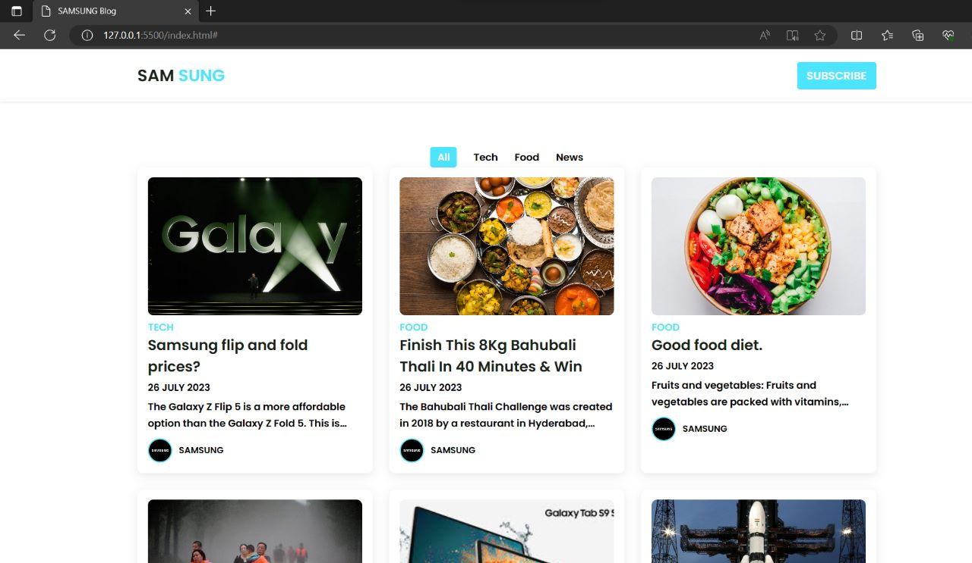**Home Section**

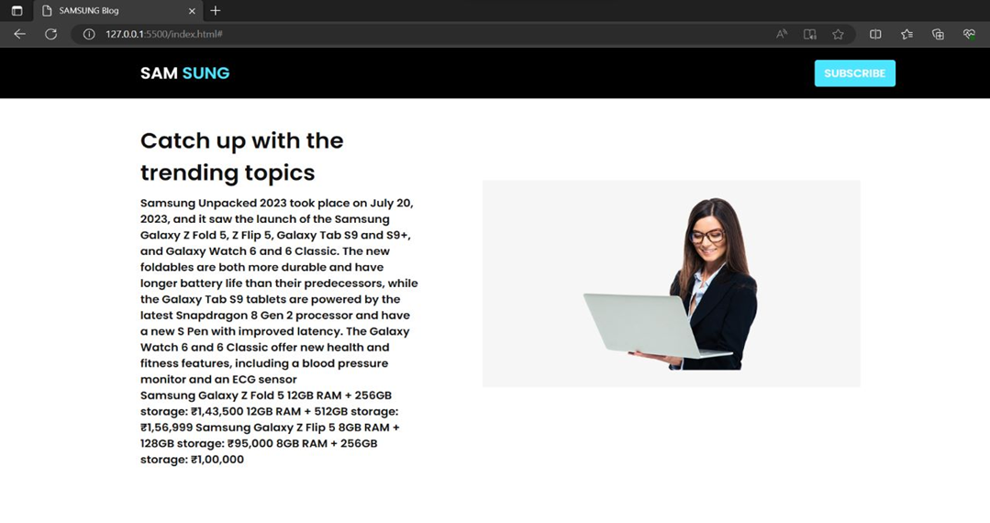

**Project Section**

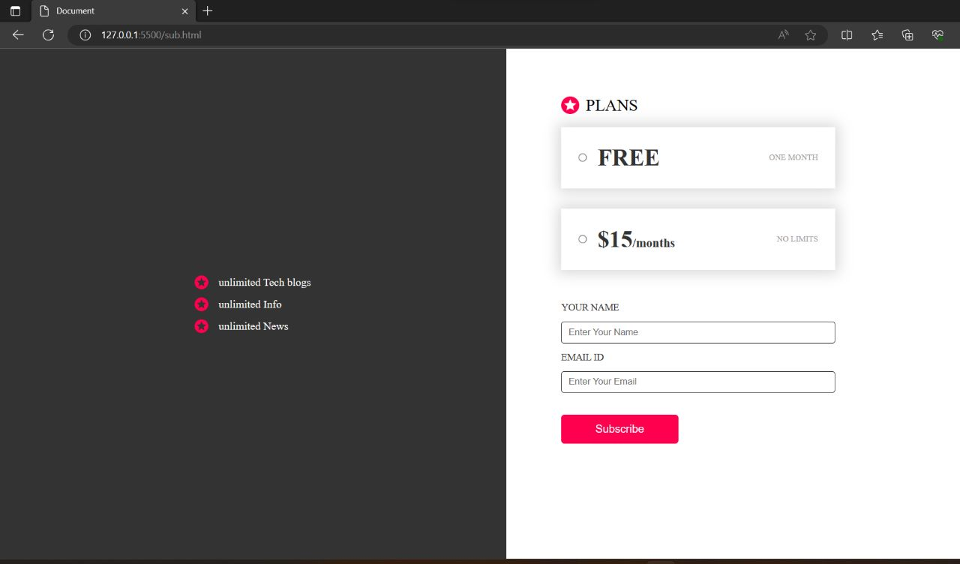

**5.ADVANTAGES AND DISADVANTAGES**

**5.1 List of advantages and disadvantages of the proposed solution**

Blogs are a big source of information used by the majority for sharing and receiving information. The following are various advantages of the blog:

**Advantages**

**1. SEO (Search Engine Optimization)**

This feature assures the presence of good content on blogs. As good content becomes a necessity to be recognized.

**2. Opportunities**

Anyone who aims to generate revenue can easily start by producing good content and attracting an audience

**3. Personal Development**

There is a big possibility of personal development. By writing posts, one can get feedback from a large number of people from all around the world.

**4. Personal Influence and User Analysis**

Large companies spend a huge amount on consumer feedback, whereas here, we get that for free. By working on posts for blogs, if we create good content, a large number of visitors get attracted. This increases personal influence.

**5. Flexibility**

This work does not require any dress code for work. This also facilitates working part-time and an ongoing full-time job. There is no boss or deadline. One can do this based on the availability of time. Also, the time allotment for working for blogs can be of an individual's choice.

**Disadvantages**

**1. Time Management**

The process of blog creation requires proper planning and thoughtfulness. This takes time. Proper planning about what to be included in the content, niche, and format to make it appreciable for large visitors.

**2. Disappointment**

From the start to gaining significant recognition and establishing momentum in blogging, the process is long, tiring, and time-taking. Results are not so visible in the short run, but they do in the long run. It is more like demanding consistency with no guarantee of success.

**3. Inconsistency and Lack of Self-Discipline**

There is always a problem of inconsistencies in posts which leads to less traffic on the website of the blog. Also, there is no boss or deadline in working on a blog which brings to the importance of self-discipline.

**4. Technical Problems**

People using WordPress faces problem, which usually include the setup time and process.

**5. Marketing**

People have limited connections. Even if they share it on social media sites, it does not contribute significantly to driving enough traffic.

**6.APPLICATIONS**

**6.1The areas where the solution can be applied.**

**Sharing news and updates:**

Use a blog app to share news and updates about your personal life or your business.

**Showcasing your expertise:**

Share your knowledge and expertise on a blog app to establish credibility and authority in your field.

**Building a community:**

Use a blog app to connect with like-minded individuals and build a community around your interests.

**Promoting products or services:**

Use a blog app to promote your products or services and reach a wider audience.

**Generating leads:**

Use a blog app to attract potential customers and generate leads for your business.

**Driving traffic to your website:**

Use a blog app to drive traffic to your website and increase your online visibility.

**Improving SEO:**

Use a blog app to improve your search engine rankings and attract more visitors to your website.

**Establishing authority:**

Use a blog app to establish yourself as an authority in your field and build a strong online presence.

**Networking with others in your industry:**

Use a blog app to network with others in your industry and build valuable connections.

**7.CONCLUSION**

**7.1 Conclusion summarizing the entire work and findings.**



The process of building a blog app requires a great attention to detail, some hard work, and lots of teamwork. But it can also be an incredibly rewarding experience that yields a user-friendly, fast, and scalable application that leaves users impressed.



After launching the app, you can sit back, relax and start creating new content. Over time, you can track user interaction, gather feedback and optimize your app for better performance. Building a great blog app can be a fulfilling and profitable experience.

**8.FUTURE SCOPE**

**8.1Enhancemets that can be made in the future.**

* Built-in social media sharing function: This would allow readers to easily share your blog posts on social media platforms like Facebook, Twitter, and Instagram, which could help increase your reach and drive more traffic to your blog.
* Customization options for the design of your blog: This would give you more control over the look and feel of your blog, allowing you to create a unique brand identity and stand out from other bloggers.
* Integration with other apps: This would allow you to connect your blog app with other apps and services, such as email marketing tools or analytics platforms, to help you better understand your audience and optimize your content.
* Adding interactive elements such as polls or quizzes: This would help engage your readers and encourage them to interact with your content, which could help increase their loyalty and keep them coming back for more.
* Monetizing your blog app through advertising or premium content and services: This would allow you to generate revenue from your blog app, either by displaying ads to your readers or by offering premium content or services that they can pay for. This could help you turn your blog into a profitable business and support your goals for growth and expansion.